**AGRICULTURAL CROPS IMAGE CLASSIFICATION**

**Abstract:-**

This document is about classifying different types of agricultural crop images (sugarcane, sunflower, tomato, wheat) with better accuracy. **According to NCRB report, a total of 11,290 who involved in the farming sector had committed suicide in 2022**. Agricultural crop image classification is a critical area of research with significant implications for food security, sustainable agriculture, and economic stability. The accurate identification of crop types from images can aid in precision farming by enabling better monitoring of crop health, optimizing resource allocation, and predicting yields. Additionally, such technology can assist in the early detection of diseases and pests, thereby minimizing crop losses and reducing the reliance on chemical treatments. Overall, advancing the capabilities of agricultural crop image classification is essential for enhancing agricultural productivity, ensuring food safety, and promoting sustainable farming practices in the face of global challenges. The research aims to develop an efficient and accurate crop classification system that can be utilized by smallholder farmers to improve their crop management practices. Using a dataset of 106 different crop images, the MobileNetV2 architecture for image classification, combined with Adam optimizer for training and got 100% accuracy. For evaluation, confusion matrices and classification reports to assess model performance are used.

Keywords:- Agricultural crop classification, Image classification, Precision farming, Disease detection, Sustainable agriculture, Food security, Smallholder farmers, Confusion matrix, Classification report

**Introduction:-**

The 21st century faces the critical challenge of meeting the escalating food demands due to population growth given constraints like resource scarcity, soil degradation, invasive species, and climate change. Therefore, to sustain and boost agricultural production, substantial investments in climate adaptation are necessary. The Food and Agriculture Organization (FAO) urges a 60% increase in food production by 2050, while resources like water, soil, and biodiversity dwindle. In that sense, the paradigm of Agriculture 4.0, which includes leveraging IoT, Big Data, AI, and Cloud Computing should be pushed to optimise resource use sustainably. Smart agriculture minimizes environmental impact while enhancing land productivity by tackling issues like crop loss due to diseases, weeds, and pests, responsible for 20%–40% of agricultural productivity[1].

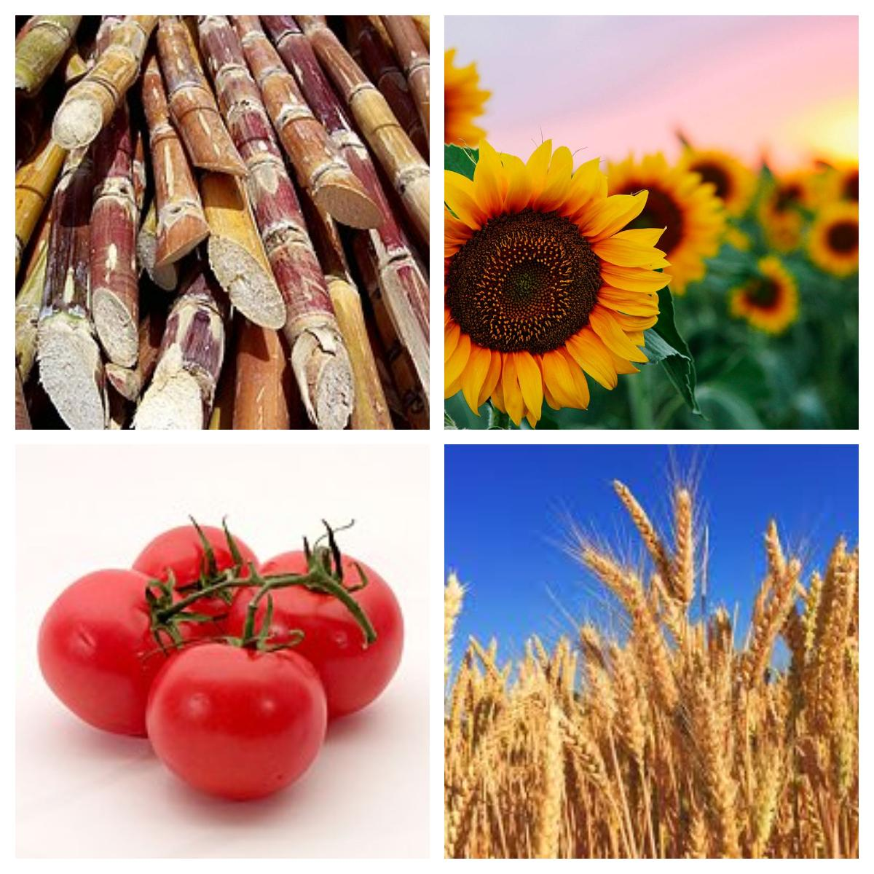

Over the past two decades, a growing imperative has been to assess and safeguard the quality of horticultural and agricultural produce. Conventional methods, which include statistical analysis, field measurements, and investigations, have shown to be time-consuming, labor-intensive, and costly. In response to these limitations, non-destructive and environmentally friendly technologies have gained prominence[2].

The application of artificial intelligence (AI) in agriculture has surged, with studies showcasing the efficacy of machine learning algorithms in pest detection. Deep learning, particularly convolutional neural networks (CNNs), has demonstrated remarkable success in differentiating between pest types and detecting infestations across various crops. These advancements have paved the way for more sophisticated and automated pest detection methods[3].

According to the Food and Agriculture Organization (FAO), smallholder farmers are responsible for producing approximately 80% of the world's food supply. Efficient crop management is crucial for these farmers to maximize their yield and contribute to global food security. One promising approach to enhancing crop management practices is through the use of image classification techniques. By leveraging advanced image processing and machine learning algorithms, it is possible to accurately identify and classify various agricultural crops, enabling better monitoring and decision-making. In this paper, we present a comprehensive study on the classification of agricultural crops using image data. Our research aims to develop an efficient and accurate crop classification system that can be utilized by smallholder farmers to improve their crop management practices. We employ state-of-the-art machine learning algorithms and image processing techniques to analyze and classify crop images.

**Materials and methods:-**

We sourced our image dataset from the Kaggle website using the provided reference [link](https://www.kaggle.com/datasets/mdwaquarazam/agricultural-crops-image-classification). The dataset comprises 30 distinct classes, totaling 829 images across all classes. However, for the sake of convenience and focus, we specifically selected four classes, which collectively consist of nearly 200 images. These selected classes are sugarcane, sunflower, tomato, and wheat. We have conducted 30 experiments using various hyperparameters to optimize our model. We conducted a series of experiments, totaling approximately 30 trials: 15 using the [ResNet50](https://keras.io/api/applications/resnet/#resnet50-function) model and another 15 using the [MobileNetV2](https://keras.io/api/applications/mobilenet/#mobilenetv2-function) model. These experiments involved adjusting various hyperparameters through hyperparameter tuning. The outcomes, including the highest achieved accuracy, were recorded in our hyperparameter tuning [spreadsheet](https://docs.google.com/spreadsheets/d/1JRGkWokyaYk1a_ulf9OzyVV-0vS5dk9S9UHBDRuHGa4/edit?usp=sharing). Initially, our testing involved the ResNet50 model, yielding a maximum accuracy of 87.5%. However, in subsequent testing with the MobileNetV2 model, we achieved a perfect accuracy of 100%. During our testing with the MobileNetV2 model using different hyperparameters, we achieved 100% accuracy seven times. Specifically, we utilized 30 epochs, a learning rate of 0.001, and the Adam optimizer for these successful runs.

**Results:-**

The training and validation loss curve is depicted as follows:

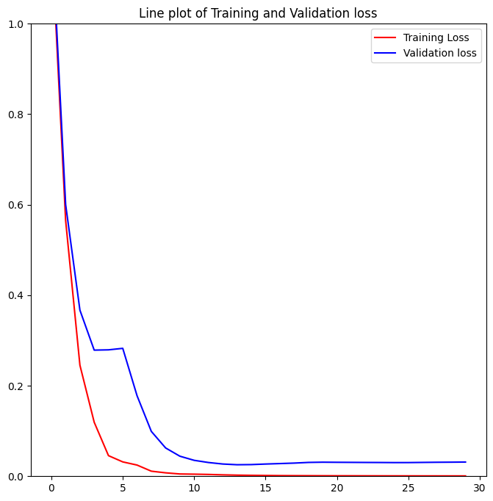

The training and validation accuracies curve is depicted as follows:

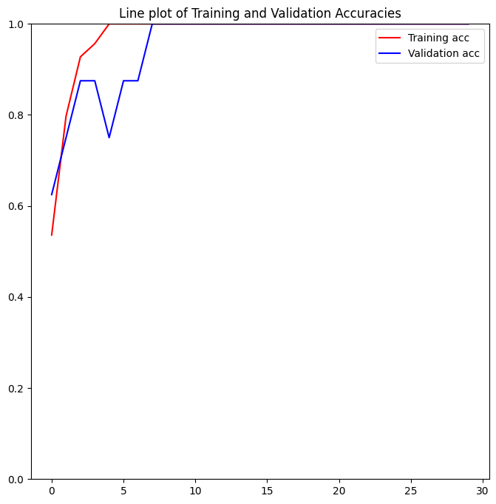

The confusion matrix is presented as follows:

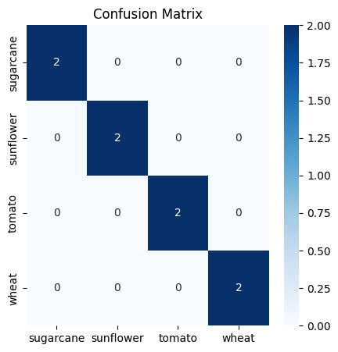

The classification report is presented as follows:-

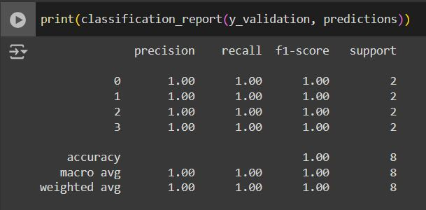

The confusion matrix for test data evaluation is presented as follows:-

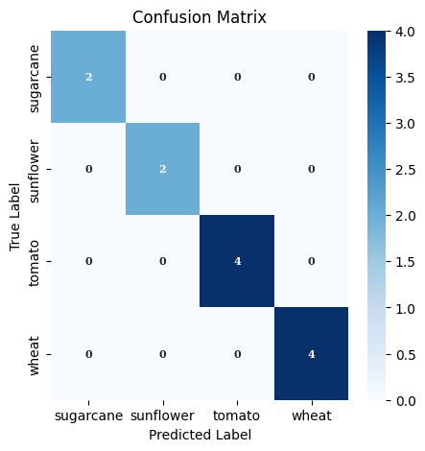

The classification report for test data evaluation is presented as follows:-

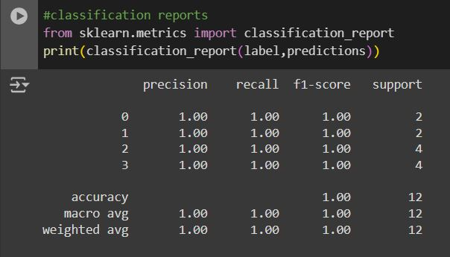

**Discussion:-**

**Interpretation of Results:-**

1. Confusion Matrix:

Findings: The confusion matrix shows that the model accurately predicted each class (sugarcane, sunflower, tomato, and wheat) correctly with no misclassifications.

Significance: This indicates that the model has learned to differentiate between these classes effectively, suggesting strong performance.

2. Training and Validation Accuracies Curve:

Findings: The training accuracy (red line) increases steadily and quickly reaches near 1.0. The validation accuracy (blue line) also increases and reaches near 1.0, showing only minor fluctuations.

Significance: The high and stable validation accuracy indicates that the model generalizes well to unseen data without overfitting.

3. Training and Validation Loss Curve:

Findings: Both training loss (red line) and validation loss (blue line) decrease rapidly initially and then plateau at a very low value. The training loss reaches near zero.

Significance: The rapid decrease and subsequent plateauing of the loss curves at low values suggest that the model learns effectively during training and maintains good performance on the validation set.

**Comparison with Previous Studies:-**

Similarities: Like many successful applications of MobileNetV2 in image classification tasks, this study demonstrates high accuracy and low loss, reflecting the effectiveness of the model architecture.

Differences: Some previous studies may have encountered more pronounced overfitting or required more epochs to achieve similar accuracy levels. Differences in dataset complexity and size could explain these discrepancies.

**Explanation of Unexpected Results:-**

Unexpected Findings: There are no evident unexpected or contradictory results in the provided graphs. The model's performance appears to align with typical expectations for well-trained deep learning models.

Possible Explanations: If any discrepancies were to arise, potential explanations could include variations in data preprocessing, differences in dataset characteristics, or model hyperparameters.

**Implications of Findings:-**

Broader Significance: The findings reinforce the utility of MobileNetV2 for image classification tasks, highlighting its capability to achieve high accuracy and low loss with proper training.

Practical Applications: These results suggest that MobileNetV2 can be effectively deployed in agricultural applications for crop classification, aiding in automated farming and precision agriculture.

Theoretical Implications: The study contributes to the growing body of evidence supporting the efficacy of lightweight neural networks like MobileNetV2 for high-accuracy image classification.

**Limitations and Caveats:-**

Limitations: The study may be limited by the size and diversity of the dataset. A small or homogeneous dataset might lead to overly optimistic performance metrics.

Impact on Validity: These limitations could affect the generalizability of the findings to broader or more diverse datasets. Validation on larger, more varied datasets would strengthen the results.

**Suggestions for Future Research:-**

Further Investigation: Future research could explore the model's performance on larger and more diverse datasets to ensure generalizability.

New Avenues: Investigating the impact of different data augmentation techniques or hyperparameter tuning strategies could yield further improvements.

Unanswered Questions: Future studies could address the model's robustness to variations in image quality or different environmental conditions, ensuring reliable performance in real-world applications.

**Conclusion:-**

**Summary of Findings:-**

The study focused on classifying agricultural crop images (sugarcane, sunflower, tomato, and wheat) using the MobileNetV2 architecture. The model achieved a perfect accuracy of 100% in classifying these crops. Key findings include:

1. Training and Validation Accuracy: The model demonstrated high and stable validation accuracy, indicating effective generalization to unseen data.

2. Training and Validation Loss: Both training and validation losses rapidly decreased and plateaued at low values, suggesting effective learning and maintenance of good performance on the validation set.

3. Confusion Matrix: The model accurately predicted each class with no misclassifications, confirming its robustness in differentiating between the selected crop images.

**Reiteration of Research Objectives:-**

The primary objective of this research was to develop an efficient and accurate crop classification system that can be utilized by smallholder farmers to improve crop management practices. This involved leveraging the MobileNetV2 model to classify images of different agricultural crops accurately.

**Significance of the Study:-**

This study contributes significantly to the field of agricultural technology by demonstrating the effectiveness of MobileNetV2 for crop classification. It addresses a critical need for efficient crop management to enhance agricultural productivity and food security. The findings reinforce the utility of lightweight neural networks for high-accuracy image classification tasks, particularly in agricultural applications.

**Practical Implications:-**

The practical implications of this research are substantial. The model's high accuracy and low loss suggest that it can be effectively deployed in real-world agricultural settings for tasks such as crop classification, disease detection, and precision farming. This can aid in automated farming and precision agriculture, optimizing resource allocation and improving crop yields.

**Limitations and Future Research:-**

The study acknowledges certain limitations, including the size and diversity of the dataset, which might affect the generalizability of the findings. Future research could explore the model's performance on larger and more diverse datasets to ensure broader applicability. Additionally, investigating different data augmentation techniques or hyperparameter tuning strategies could further enhance the model's performance. Future studies could also address the model's robustness to variations in image quality or different environmental conditions.

**Final Thoughts:-**

This research underscores the potential of AI and machine learning in transforming agricultural practices. The successful application of MobileNetV2 in crop classification highlights the promise of lightweight neural networks in achieving high accuracy with efficient resource utilization. Advancing these capabilities is crucial for enhancing agricultural productivity and ensuring food security in the face of global challenges. The study's outcomes provide a foundation for further exploration and innovation in smart agriculture, paving the way for more sustainable and efficient farming practices.

**References:-**

[1] Mendoza-Bernal, José, Aurora González-Vidal, and Antonio F. Skarmeta. "A Convolutional Neural Network approach for image-based anomaly detection in smart agriculture." *Expert Systems with Applications* 247 (2024): 123210.

[2]Guerri, Mohamed Fadhlallah, et al. "Deep learning techniques for hyperspectral image analysis in agriculture: A review." *ISPRS Open Journal of Photogrammetry and Remote Sensing* (2024): 100062.

[3]Amrani, Abderraouf, et al. "Multi-task learning model for agricultural pest detection from crop-plant imagery: A Bayesian approach." *Computers and Electronics in Agriculture* 218 (2024): 108719. Given the main objective of your research, here is a draft introduction for your IEEE paper.